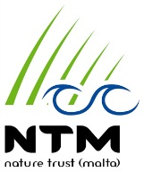
Nature Trust Malta
Membership Form / Renewal 2017

Name: | Surname:
House Address:

Email Address:

Telephone Number: | Mobile Number:
ID Number: | Date of Birth:
Other Family Members (please include date of birth and email address)

Date: | Signature:
Year you joined NTM (in case of renewal)

If interested in being an Active Member kindly indicate areas
Activities and Events
Fundraising and marketing
Manning NTM stands in Fairs etc
Helping at the Indigenous tree Nursery
Patroling NTM sites and Guiding visitors
Hedgehog Rescue and or Rehabilitation
Clean ups
Design of material
Office work

Please note that all data in this membership form will be
kept confidential as per data protection act.

